Lab Exercise 7
Integrating Maven with Jenkins

Objective: To install the Maven plugin in Jenkins for smooth integration and automation of Maven-based build processes within the Jenkins environment

Tools required: Git, GitHub, and Jenkins

Prerequisites: None

Steps to be followed:
- Install the Maven plugin
- Set up Global Tool Configuration
- Fork a sample repository
- Integrate Maven with Jenkins

Step 1: Install the Maven plugin

- Open the browser, go to the Jenkins Dashboard by typing localhost:8080 in your browser, provide the credentials, and click the Sign in button



- Click on the Manage Jenkins option as shown in the screenshot below:

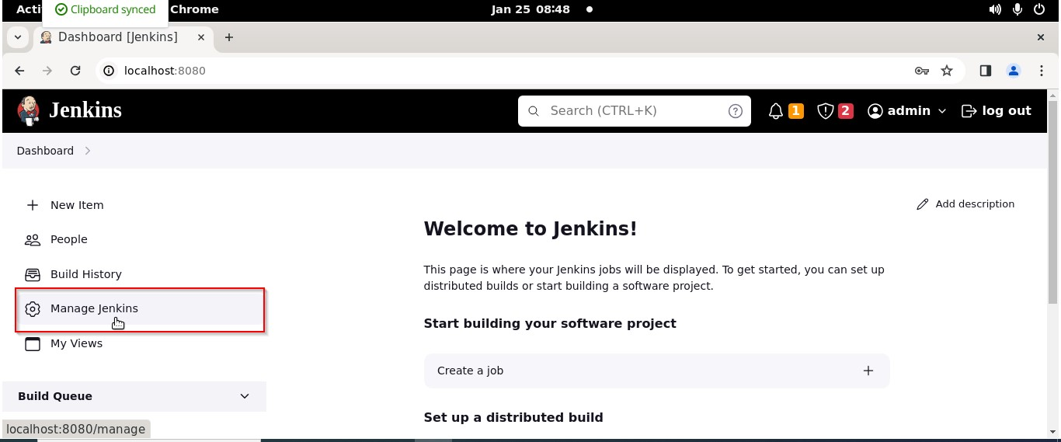

Output:-

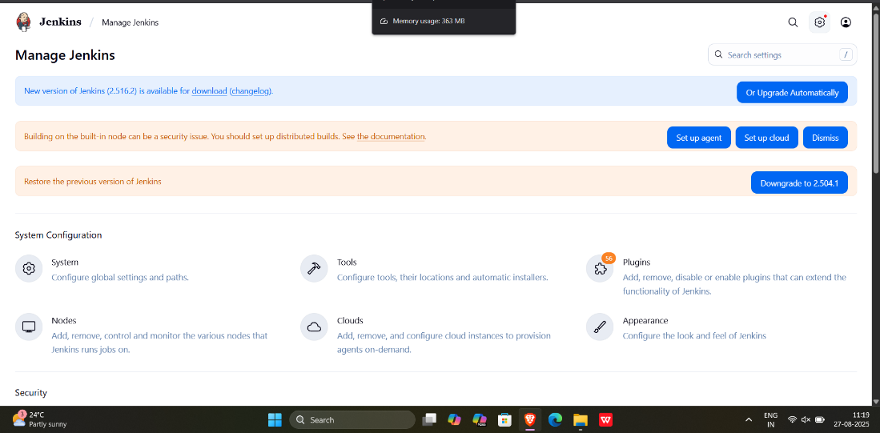

- Click on the Plugins option as shown in the screenshot below:
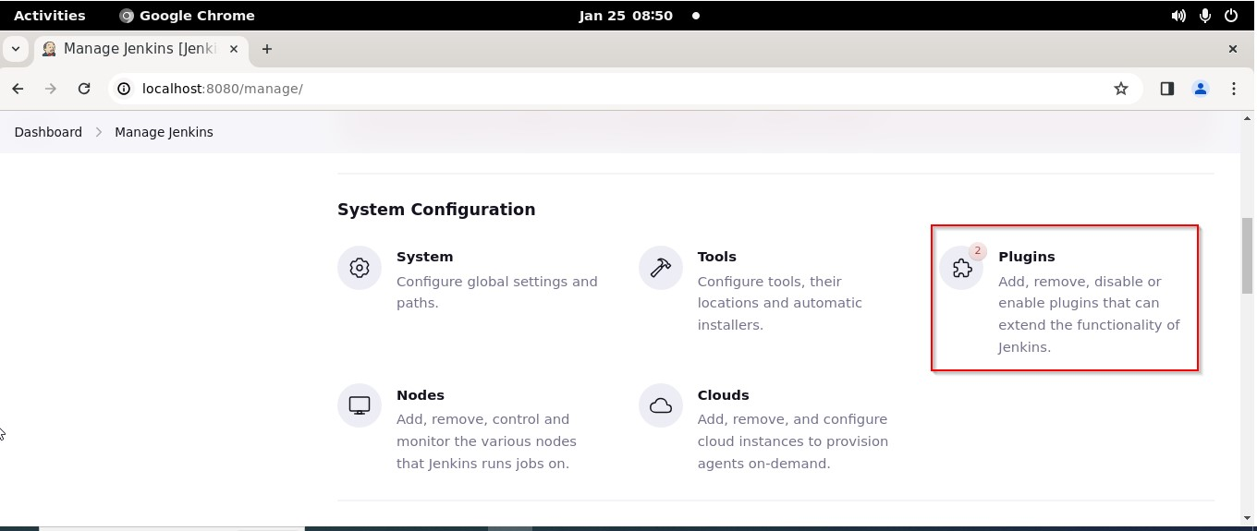

- Click on Installed plugins to verify whether the Maven Integration plugin has been installed

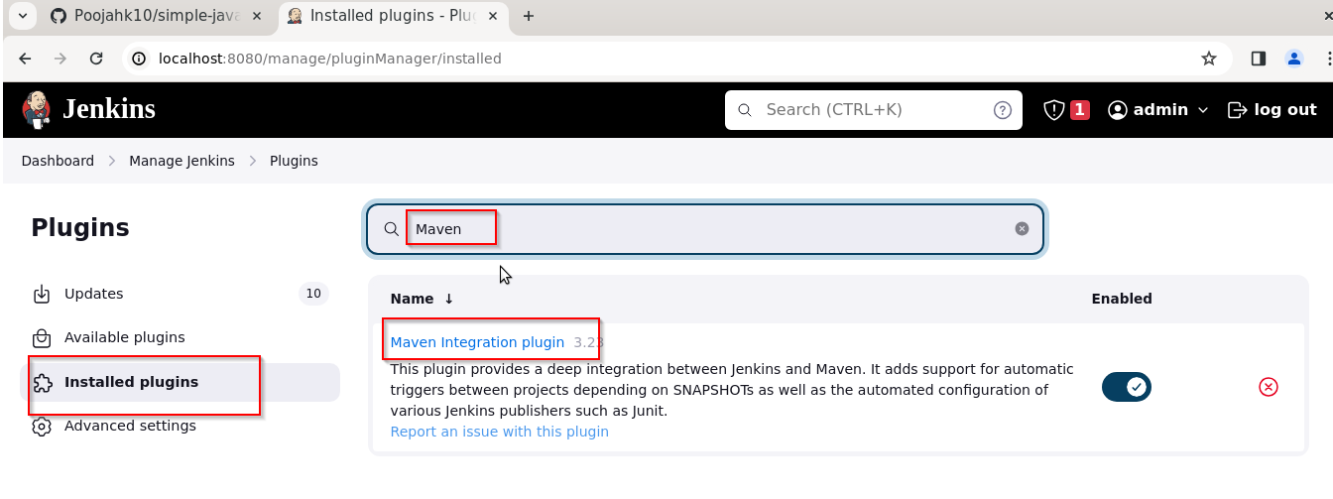

Note: Maven is already installed in your practice lab environment. If not, click on Available plugins, search for the Maven Integration plugin, and install it.

Output:-

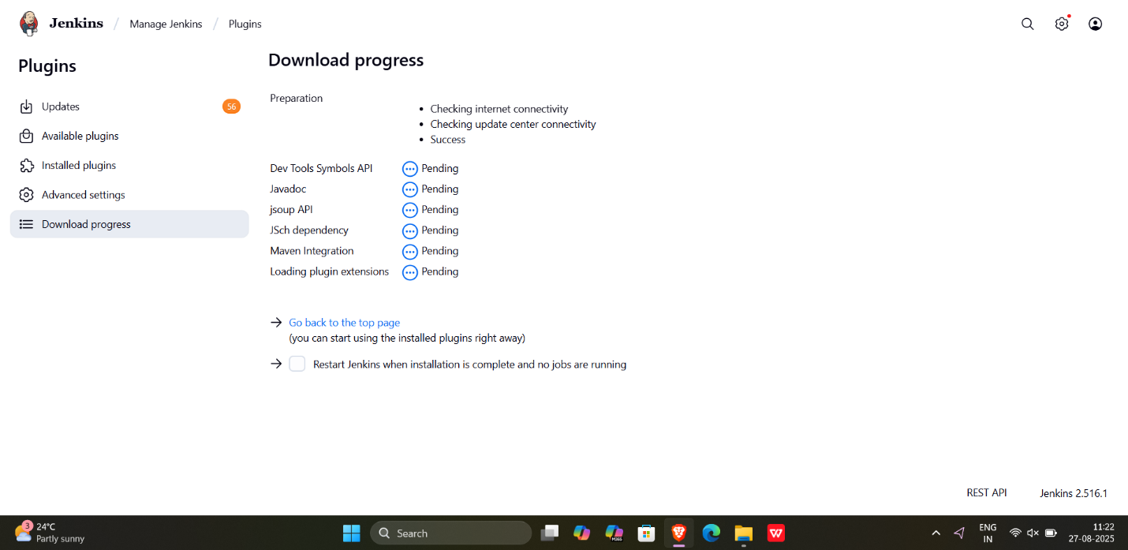

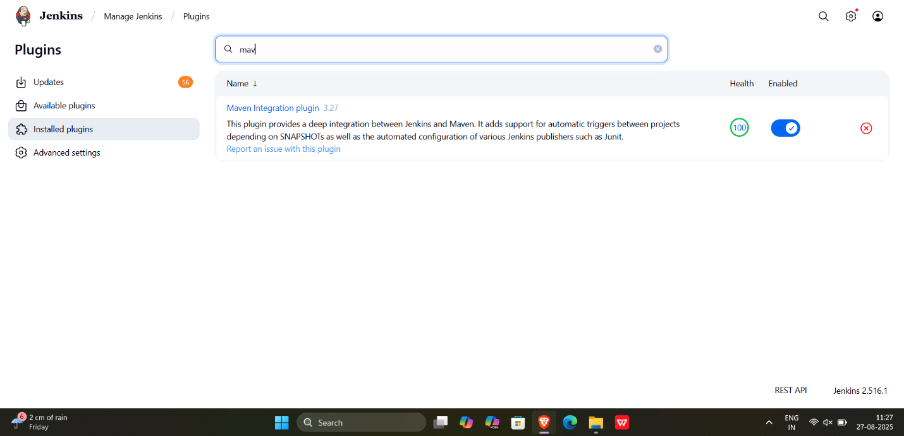

- Use the following command to check the Maven version:
mvn -version

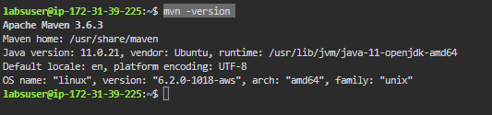

Output:-

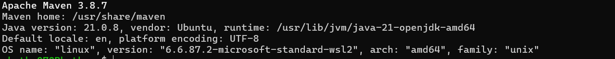

Step 2: Set up Global Tool Configuration

- Go to the Jenkins Dashboard, click on Manage Jenkins, and then select Tools from the list of options

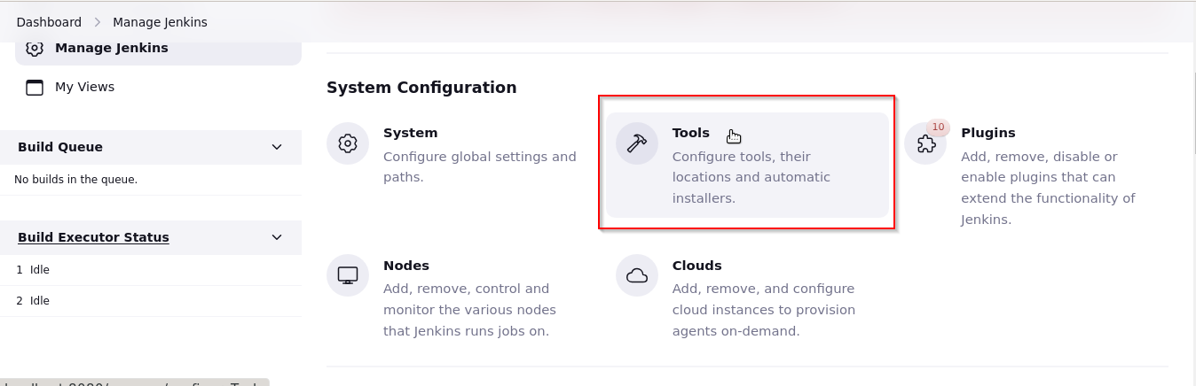

- To configure Maven, click on the Maven installations button in the Maven section and enter a Name and MAVEN_HOME path

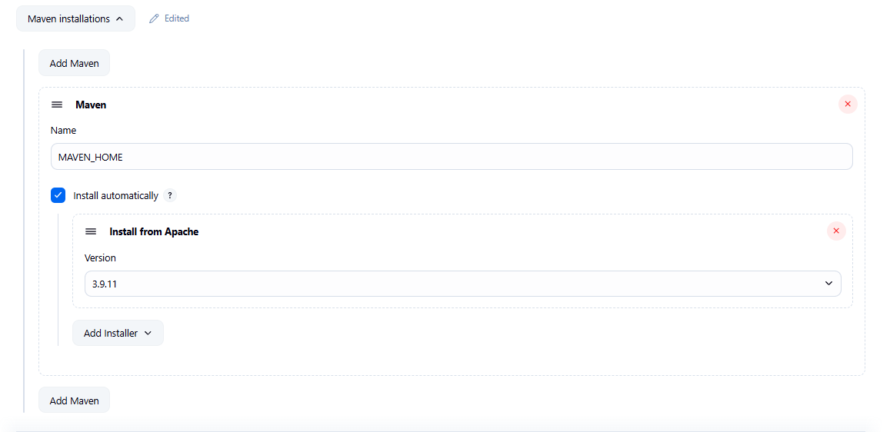

Output:-

